Cody Graham

**Final Website Planning Document**

**Site Purpose:**

Templeinn.net is a site that provides information about the hotel chain, The Temple Inn & Suites, that caters mainly to temple patrons and workers. The site contains detailed info about several temples (four of my choosing), an online reservation service, a page that describes the various services offered by the hotel chain for things like wedding receptions and full-time temple missionary housing. IT will also have a page containing necessary contact info for the hotel chain.

**Target Audience:**

Temple patrons, workers (and their families), and temple missionaries are the main target audience for this site. However, the hotel still operates like any other and accommodates any who are perhaps traveling and would like to stay at the various locations offered. The motivation for the target audience to use this site would be when they are working in or visiting a temple far away from their home and need places to stay while in the area that are nearby the temple grounds.

**Site Map:**

**Color Scheme:**

**Background:** Light Gray - #e6e6e6 and variations and transparencies; White.

**Font:** Navy **-** #010046 and several variations and transparencies; Black.

**Typography:**

**Font:** Verdana

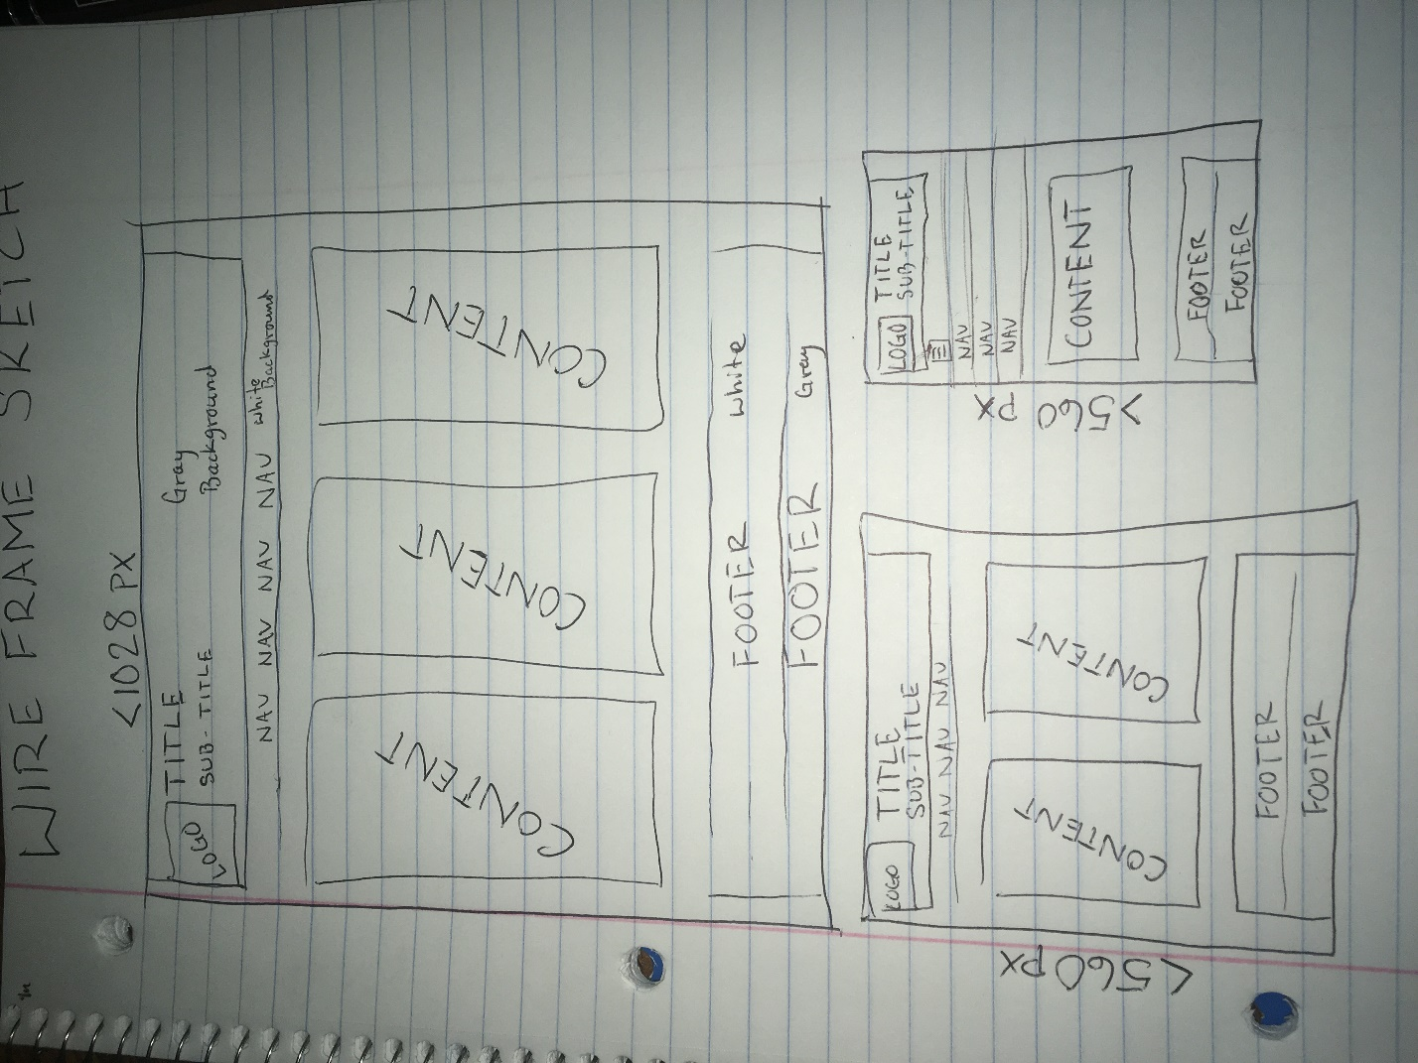**Wireframe:**